But first of all, we had three equations for three function, but actually\displaystyle{{\frac{dS}{dt}}+{\frac {dI}{dt}}+{\frac {dR}{dt}}=0}so it means that our problem is here simply in dimension 2. Hence\displaystyle {\begin{aligned}&X={\frac {dS}{dt}}=\mu(N-S)-{\frac {\beta IS}{N}},\\[6pt]&Y={\frac {dI}{dt}}={\frac {\beta IS}{N}}-(\mu+\gamma)I\end{aligned}}and therefore, the Jacobian of the system is\begin{pmatrix}\displaystyle{\frac{\partial X}{\partial S}}&\displaystyle{\frac{\partial X}{\partial I}}\\[9pt]\displaystyle{\frac{\partial Y}{\partial S}}&\displaystyle{\frac{\partial Y}{\partial I}}\end{pmatrix}=\begin{pmatrix}\displaystyle{-\mu-\beta\frac{I}{N}}&\displaystyle{-\beta\frac{S}{N}}\\[9pt]\displaystyle{\beta\frac{I}{N}}&\displaystyle{\beta\frac{S}{N}-(\mu+\gamma)}\end{pmatrix}We should evaluate the Jacobian at the equilibrium, i.e. S^\star=\frac{\gamma+\mu}{\beta}=\frac{1}{R_0}andI^\star=\frac{\mu(R_0-1)}{\beta}We should then look at eigenvalues of the matrix.

|  |  |
| --- | --- |
| 1  2  3  4  5 | times = **seq**(0, 100, **by**=.1)  p = **c**(mu = 1/100, N = 1, **beta** = 50, **gamma** = 10)  start_SIR = **c**(S=0.19, **I**=0.01, R = 0.8)  resol = ode(y=start_SIR, **t**=times, func=SIR, p=p)  **plot**(resol[,"time"],resol[,"I"],type="l",xlab="time",ylab="") |

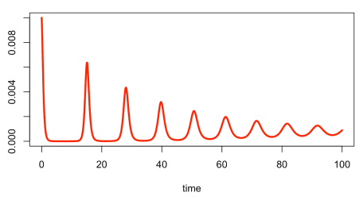

We can compute values at the equilibrium

|  |  |
| --- | --- |
| 1  2  3  4 | mu=p["mu"]; **beta**=p["beta"]; **gamma**=p["gamma"]  N=1  S = (**gamma** + mu)/**beta**  **I** = mu * (**beta**/(**gamma** + mu) - 1)/**beta** |

and the Jacobian matrix

|  |  |
| --- | --- |
| 1  2 | J=**matrix**(**c**(-(mu + **beta** * **I**/N),-(**beta** * S/N),  **beta** * **I**/N,**beta** * S/N - (mu + **gamma**)),2,2,byrow = TRUE) |

Now, if we look at the eigenvalues,

|  |  |
| --- | --- |
| 1  2 | **eigen**(J)$values  [1] -0.024975+0.6318831i -0.024975-0.6318831i |

or more precisely 2\pi/b where a\pm ib are the conjuguate eigenvalues

|  |  |
| --- | --- |
| 1  2 | 2 * **pi**/(**Im**(**eigen**(J)$values[1]))  [1] 9.943588 |

we have a [damping period](https://physics.stackexchange.com/questions/158426/does-damping-force-affect-period-of-oscillation) of 10 time lengths (10 days, or 10 weeks), which is more or less what we’ve seen above,

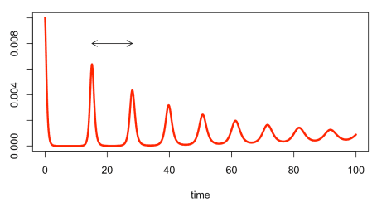

The graph above was obtained using

|  |  |
| --- | --- |
| 1  2  3  4  5  6  7  8  9 | p = **c**(mu = 1/100, N = 1, **beta** = 50, **gamma** = 10)  start_SIR = **c**(S=0.19, **I**=0.01, R = 0.8)  resol = ode(y=start_SIR, **t**=times, func=SIR, p=p)  **plot**(resol[1:1e5,"time"],resol[1:1e5,"I"],type="l",xlab="time",ylab="",lwd=3,**col**="red")  yi=resol[,"I"]  dyi=**diff**(yi)  i=**which**((dyi[2:**length**(dyi)]*dyi[1:(**length**(dyi)-1)])&lt;0)  **t**=resol[i,"time"]  **arrows**(**t**[2],.008,**t**[4],.008,**length**=.1,code=3) |

If we look carefully. at the begining, the duration is (much) longer than 10 (about 13)… but it does converge towards 9.94

|  |  |
| --- | --- |
| 1  2 | **plot**(**diff**(**t**[**seq**(2,40,**by**=2)]),type="b")  **abline**(h=2 * **pi**/(**Im**(**eigen**(J)$values[1])) |

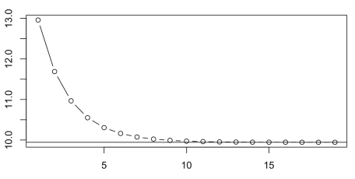

So here, theoretically, every 10 weeks (assuming that our time length is a week), we should observe an outbreak, smaller than the previous one. In practice, initially it is every 13 or 12 weeks, but the time to wait between outbreaks decreases (until it reaches 10 weeks).